EXPERIMENT-14
14. A nutrition application recommends diet plans based on age, BMI, and health conditions. Develop a Diet Recommendation Expert System. Recommend personalized diet plans using rules.

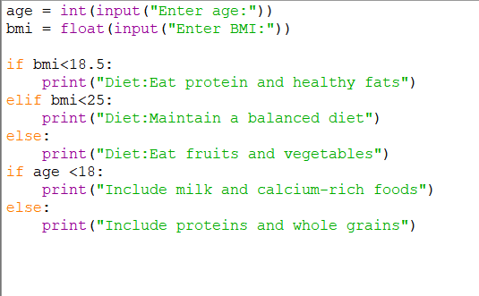
PROGRAM:

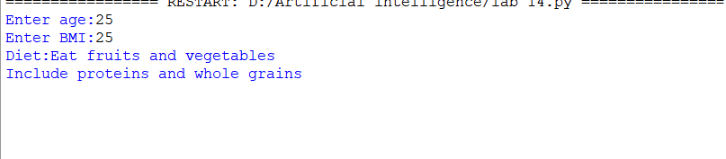
OUTPUT:

